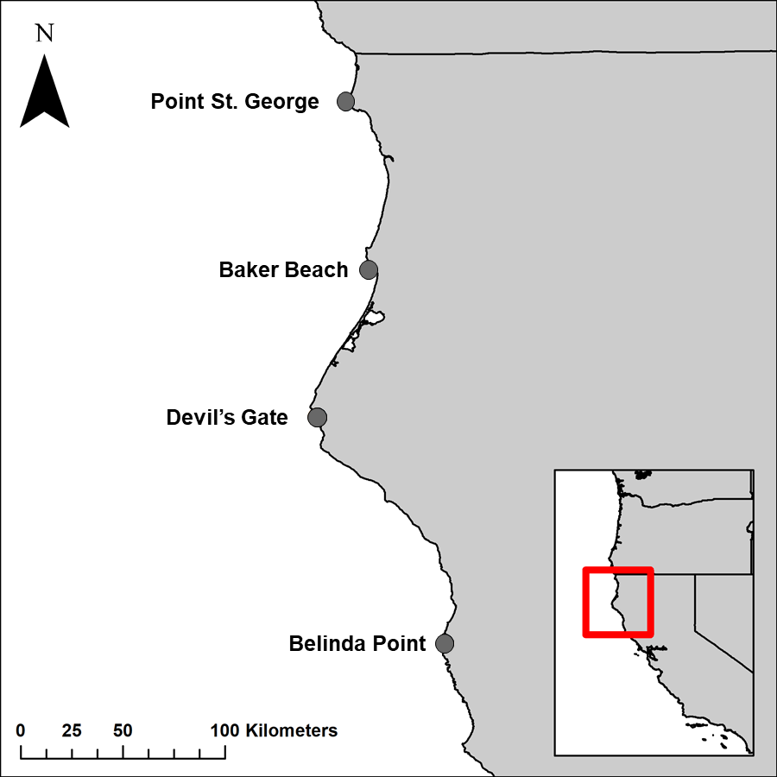
Figure 1. Location of each field site in northern California, USA. Map created in the Geospatial Information System ArcMap (10.6.1).
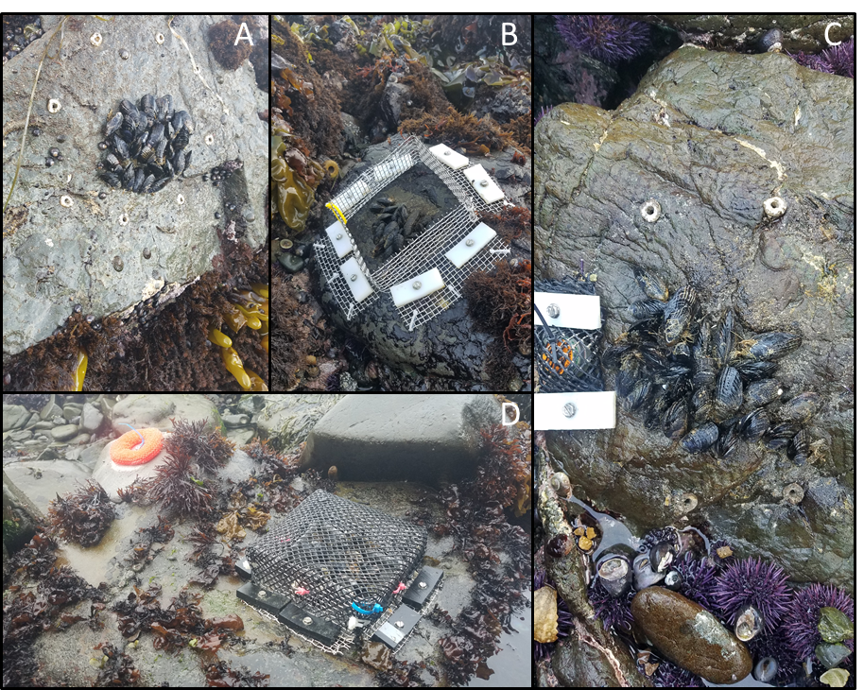
Figure 2. Examples of (A) Pisaster plots, (B) rock crab plots, (C) Pisaster + rock crab plots, and (D) Control plots installed at each site. Note the presence of the TuffyTM scouring pad in the MPE plot (C).

Figure 3. Boxplots depicting differences in mussel recruitment between A) sites and B) horizontal and vertical orientations, and differences in predator density between C) sites and D) Pisaster and rock crabs. Site abbreviations: PSG = Point St. George, DG = Devil's Gate, BP = Belinda Point. Points represent outliers.

Figure 4. Proportion of living mussels across predator treatments at each site. Large points represent means and error bars represent ± 1 SE. Control treatments have no error bars due to 100% survival across all replicates. Small transparent points represent raw data for each predator treatment within each site.

Figure 5. Per population (A) and per capita (B) interaction strength of predator treatments across sites. Points represent estimated interaction strengths and error bars represent 95 % confidence intervals.

Figure 6. Average number of mussels consumed by A) Pisaster and B) rock crabs within laboratory predator treatments. Error bars represent ± 1 SE.

